

**Experience SAP HANA Cloud Portal**

**Create engaging business-driven sites that leverage data from other on-premise and cloud solutions**

Table of ContentS

Welcome 1

TUTORIAL Agenda 1

Prerequisites 1

Exercise 1: Setting up the Work Environment 2

Set up your environment 2

Access your trial account 2

Start Eclipse 2

Verify your environment 3

Verify Eclipse proxy settings 3

Verify target runtime settings 4

Verify HANA Cloud server settings 5

Deploy a Public Destination 6

Configure proxy settings 6

Deploy the destination for the CRM back end 6

Deploy the destination for the Google API server 7

Get the source code 7

Import the source code into Eclipse 8

Note: Associating the project with the HANA Cloud target runtime 9

View the AtomicContent project tree 9

Exercise 2: Creating Opensocial widgets 11

Create the widgets for the Venues page 11

Create the Venue List widget (the publisher) 12

Include image resources 16

Create the spec XML of the widget 16

Create the Venues Map widget (the subscriber) 16

Create a new folder 16

Create a new JavaScript file 16

Append the code for using the sap-context feature 17

Create a new HTML file 18

Create a new CSS file 18

Create the spec XML of the widget 19

Review the *Registration Form* widget 19

About the HTTP destination 22

Review the JAM Login widget 24

Open the spec XML of the Jam Login widget 24

Open the JavaScript file of the *Jam Login* widget 24

Exercise 3: Adding the widgets to cloud portal 25

Deploy the widgets to HANA Cloud 25

Open the New Server wizard 25

Create a new server 25

Test the URLs to the widget files 27

Add the widgets to Cloud Portal with auto-discovery 27

View the widgets in Cloud Portal 28

Manually create widgets for use in Cloud Portal 28

Navigate to the CONTENT tab 28

Add the widgets 29

Exercise 4: creating and configuring a new cloud portal site 29

Manage content in the Content Catalog 29

Manage files in the Document Repository 30

Import a site from the Cloud Portal Market Place 31

Configure site design settings 32

Exercise 5: Managing Pages and Content in Your Site 32

Delete a page 32

Add new pages to the site 32

Add content to the *Venues* page 33

Add content to the Jam Discussions page 34

Customize the Jam Discussionspage header and footer 35

Update the About the Event page 36

Update the Registration page 37

Remove the page grid 37

Exercise 6: ENHANCING THE site layout and theme 38

Customize the site background and page navigation bar 38

Download the theme 38

Edit the general settings of the site 38

Edit the page navigation bar settings 39

Upload the new theme and apply it to the site 39

Exercise 7: previewing the site and publishing it 40

Preview the site 40

Publish the site and edit the site URL 40

View the site in consumption mode 40

Access the site with your mobile device 40

View the site usage analytics 40

exercise 8: exploring advanced site management and authoring features 41

Manage page hierarchies 41

Revert changes made to the site 41

Set a URL for downtime 41

Appendix: Setting up Your Trial Account 42

# Welcome

Welcome to our partner hands-on workshop for SAP HANA Cloud Portal site and content development. We intend to accompany you as you develop widgets for your Cloud Portal site, deploy them to SAP HANA Cloud, and then build your complete site in SAP HANA Cloud Portal. After this session, you will have the knowledge and skills to:

* Work in the Eclipse environment to develop a range of widgets for deploying to the cloud
* Create Cloud Portal sites
* Populate the site pages with the content you have developed
* Preview the site and publish it
* Understand how you can easily author engaging sites that expose cloud-based social and business applications

# TUTORIAL Agenda

* 1. **Setting up the Work Environment**

To begin, you will activate your SAP HANA Cloud account (if you haven’t already), access the Eclipse working environment, and become familiar with the tools that you will use for developing your widgets for your portal site.

* 1. **Creating OpenSocial Widgets**

In this section, you will create OpenSocial widgets for your Cloud Portal site. Also, you will review the code of a number of additional preconfigured widgets so that you can learn about different aspects of the code.

* 1. **Adding the Widgets to Cloud Portal**

You will then deploy your widgets to SAP HANA Cloud. Then, you will add those widgets to SAP HANA Cloud Portal.

* 1. **Creating and Configuring a New Cloud Portal Site**

Once your content is ready, you will create a new Cloud Portal site based on an existing site that you import from the Cloud Portal Market Place.

* 1. **Managing Pages and Content in Your Site**

In this exercise, you will focus on finalizing your page structure, and assigning page layouts by using the provided page templates.

* 1. **Enhancing the Site Layout and Theme**

You will now create a theme for your site and apply it to the site pages.

* 1. **Previewing the Site and Publishing It**

Before you publish your site for end users, you can preview it on the different devices.

* 1. **Exploring Advanced Site Management and Authoring Features**

Now that your site is complete and published, you will learn about additional features for building your Cloud Portal sites.

# Prerequisites

* You have the following installed on your machine:
  + Chrome browser, for use in all of the exercises in this tutorial
  + Java Development Kit (JDK)
  + Notepad++
* You have established a trial account for SAP HANA Cloud Portal and have your SAP ID or SCN credentials.   
  **Note**: You will need to use the name and password of your trial account in some of the exercises.

***Good luck with your content development.***

# Exercise 1: Setting up the Work Environment

In this exercise, you will initiate a free HANA Cloud trial account, start the Eclipse IDE, verify the HANA Cloud settings, and import a simple web application to host your widget resources.

## Set up your environment

If you do not have a trial HANA Cloud account, see the appendix for the relevant instructions.

## Access your trial account

* 1. Open your Chrome browser
  2. Go to <https://account.hanatrial.ondemand.com/cockpit>.
  3. From the side-panel menu at the left, click *Services*.
  4. From the *Services* list, click *SAP HANA Cloud Portal*. Cloud Portal opens, displaying the Site Directory.

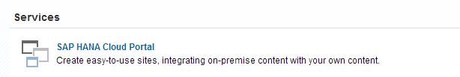

Start Eclipse

* 1. Open thePartner Testfolder on your file system [C:/pt2014/].
  2. Open the eclipse folder and run eclipse.exe. This starts a preconfigured Eclipse that has been prepared for this event.
  3. When starting the Eclipse –
     + 1. Choose the preconfigured CP Workspace:

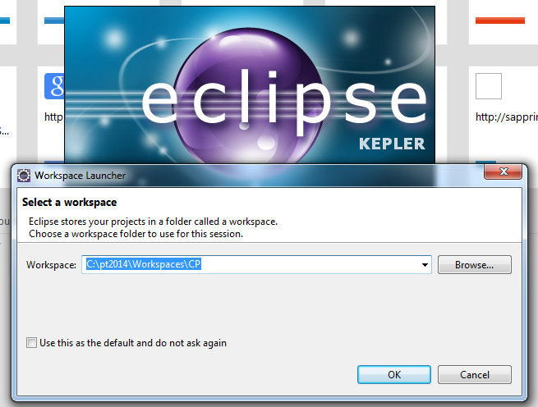

* + - 1. Or switch to the *CP* workspace once the Eclipse is already open:
         1. Click File > Switch Workspace.
         2. Select the CP workspace.

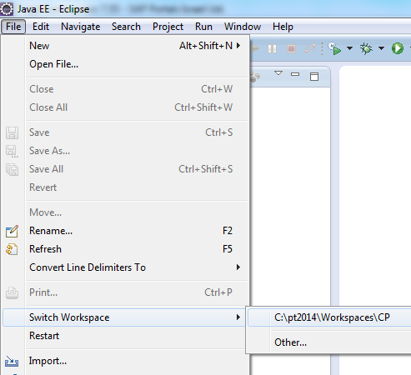

## 

## Verify your environment

Verify target runtime settings

* 1. Click *Window* > *Preferences*
  2. In the navigation panel of the *Preferences* window, select *Server* > *Runtime Environments*.

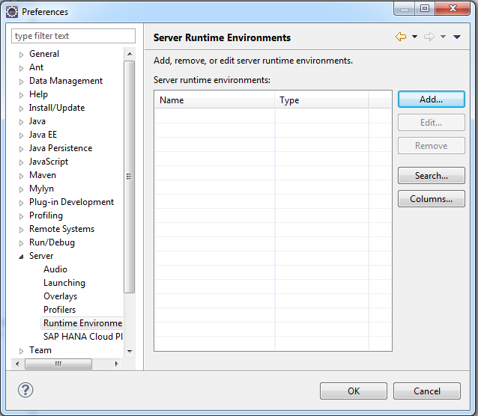

* 1. Click *Add*. The *New Server Runtime Environment* wizard opens.

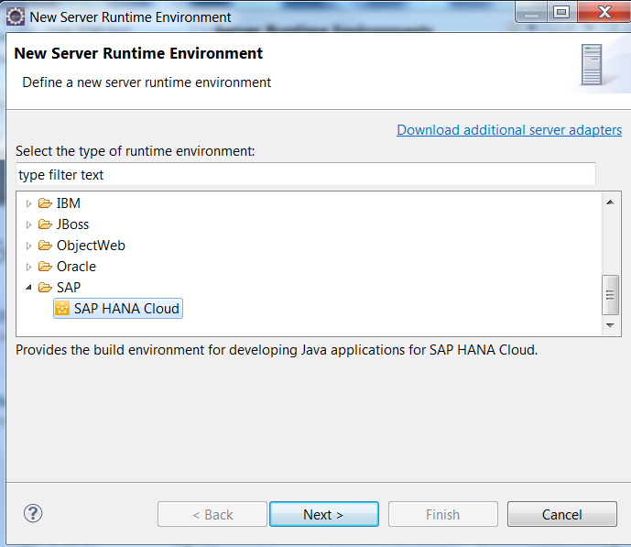

* 1. Select *SAP* > *SAP HANA Cloud*.
  2. Click *Next*.

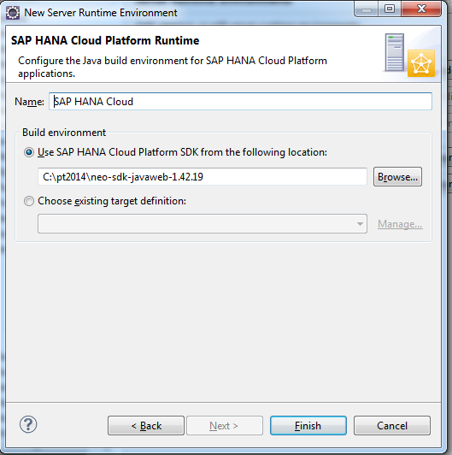

* 1. Enter the information as follows:
  + **Name**: SAP HANA Cloud
  + **Build environment**: Select *Use SAP HANA Cloud SDK from the following location*
  + Click *Browse* and go to the partner test folder. Navigate to neo-sdk-javaweb-1.42.19 root folder.
  1. Click *OK*.
  2. Click *Finish*.

Verify HANA Cloud server settings

* 1. In the navigation panel of the *Preferences* window, select *Server* *> SAP HANA Cloud Platform*.

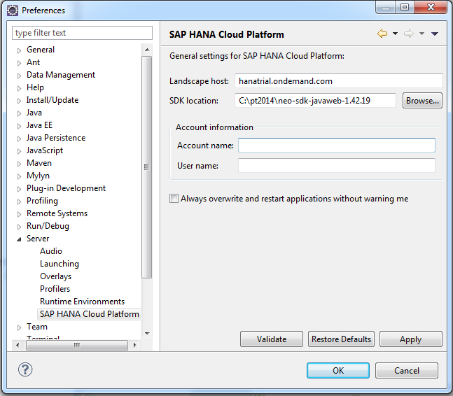

* 1. Verify the following fields:
  + *Landscape host:* hanatrial.ondemand.com
  + *SDK location*: C:\pt2014\neo-sdk-javaweb-1.42.19  
    If this location does not appear, browse to the location as shown in step ‎9.
  1. Update the *Account information* fields:
  + *Account name:* <your user ID>trial (e.g. i042970trial)*.*Use only lower case letters.
  + *User name:* <your user ID>
  1. Click *Validate* and verify a positive validation result in the popup window.
  2. Click *OK*.

## 

## Deploy a Public Destination

In this scenario, you will build a public site that everyone can access without passing any authentication process; therefore a widget can send requests only to the domain in which the Cloud Portal is hosted. Requests to other domains can be made via public destinations.

In this step, you will define public destinations that you will use for requests to other servers.

Configure proxy settings

* 1. Navigate to the Neo SDK folder in your partners test folder:  
     C:\pt2014\neo-sdk-javaweb-1.42.19\tools.
  2. Notice, in this folder we prepared two destination properties files relevant to this exercise  
     crm__public and google__public.
  3. Open a command line with administrator privileges
     + 1. Open the Windows OS *Start* menu
       2. Click *All Programs* > *Accessories*
       3. Right click *Command Prompt*
       4. Choose *Run as administrator*

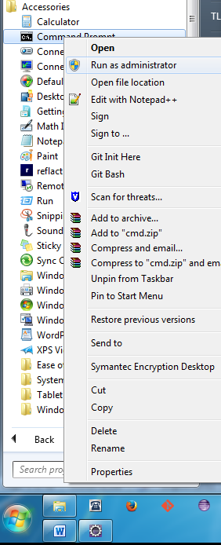

* 1. In the and command line change directory to the tools folder by using the following **cd** command:  
     cd c:\pt2014\neo-sdk-javaweb-1.42.19\tools\
  2. Use the **dir** command to see the destination properties files.  
       
     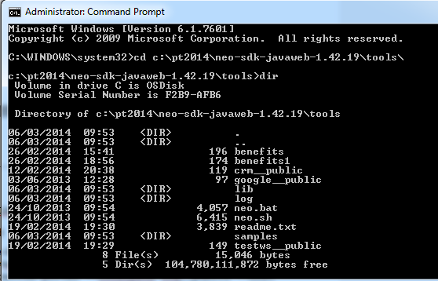
  3. Set proxy settings by running the following commands:

**set HTTP_PROXY_HOST=proxy  
set HTTP_PROXY_PORT=8080  
set HTTPS_PROXY_HOST=proxy  
set HTTPS_PROXY_PORT=8080  
set HTTP_NON_PROXY_HOSTS="localhost"**

Deploy the destination for the CRM back end

* 1. Run the following command to deploy the destination for the CRM back-end:  
       
     neo put-destination --account <account_name> --user <user_name> --provider-account trial --provider-application portal --localpath crm__public --host hanatrial.ondemand.com  
       
     For example:  
     neo put-destination --account i034051trial --user i034051 --provider-account trial --provider-application portal --localpath crm__public --host hanatrial.ondemand.com

**TIP**: Copy the command to Notepad, replace <user_name> with your user name, and paste into the command line.

* 1. Enter your trial account password and press *Enter*.

A message appears when the destination has been successfully deployed.

Deploy the destination for the Google API server

* 1. Run the following command to deploy the destination for the Google API server:

**neo put-destination --account <account_name> --user <user_name> --provider-account trial --provider-application portal --localpath google__public --host hanatrial.ondemand.com**

* 1. Enter your trial account password and press Enter.  
     A message appears when the destination has been successfully deployed.  
     You will use these destinations when you develop the widgets for this scenario.
  2. Close the command window.

## Get the source code

Download the source code for the *Atomic Content* application from GitHub.

* 1. In your Chrome browser, navigate to <https://github.com/SAP/cloud-portal-widgets>.
  2. Click *Download Zip* at the right
  3. Save the cloud-portal-widgets-master.zip to your file system.
  4. Extract the ZIP file in into the partner test event folder C:\pt2014
  5. The extracted folder contains the following subfolders:
  + AtomicContent – Contains the Web-application project that you will develop
  + Resources – Contains the resources needed to create your HANA Cloud Portal site
  + AtomicContent_Solution – Contains the final Web-application project – you can disregard this folder

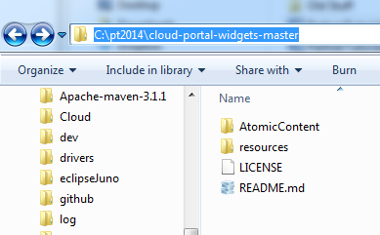

## Import the source code into Eclipse

Import the Web-application project that you extracted from the ZIP file into Eclipse.

* 1. In the top menu click *File* > *Import* >
  2. Select *General* > *Existing Projects into Workspace*

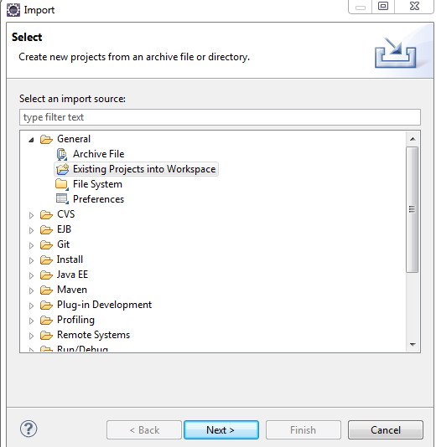

* 1. Click *Next.*
  2. Click *Browse* and navigate to the root folder.
  3. Navigate to the AtomicContent folder [C:\pt2014\cloud-portal-widgets-master\AtomicContent]

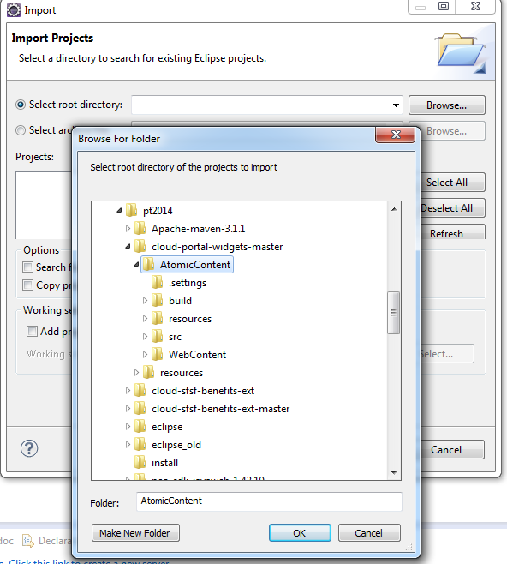

* 1. Select the root folder of the Web Application - *AtomicContent*
  2. *C*lick *OK.*
  3. Click *Finish* to import the selected project into your workspace
  4. The project is automatically built by Eclipse notice the progress bar on the bottom right  
     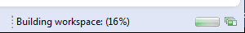

Note: In Case the Project Build Fails

In case the automatic build of the project terminates with errors (project is marked with a red *X*), you may need to associate the project with the HANA Cloud target runtime you defined earlier. In this case perform the following:

* 1. Right-click on the project root folder and select *Properties* > *Targeted Runtimes.*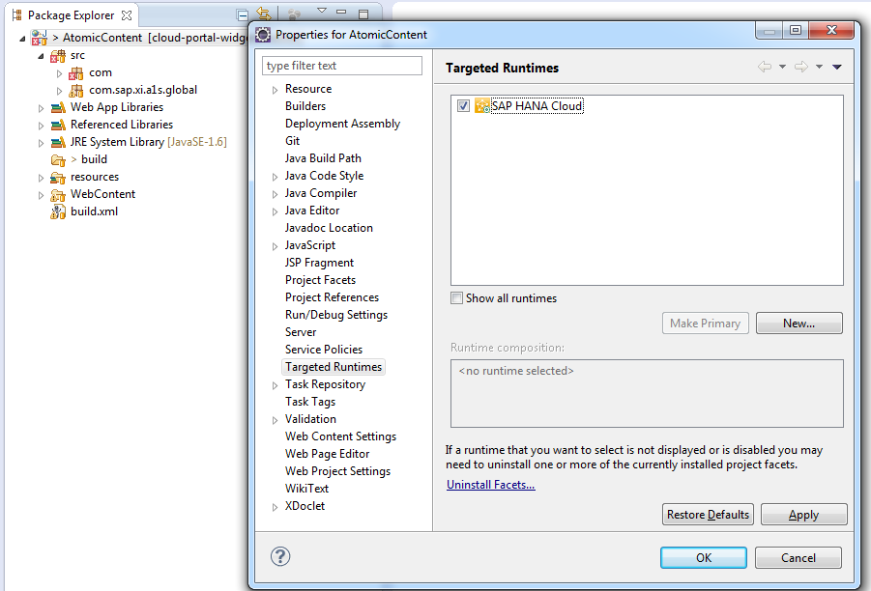
  2. Ensure that the *SAP HANA Cloud* runtime checkbox is selected.
  3. Click *OK.*

View the AtomicContent project tree

* 1. In the *Package Explorer* tab, expand the AtomicContent project tree.

The AtomicContent application is split into two main components: back end and front end.

* 1. The WebContent folder contains the **front end**.
  2. Under the WebContent folder, expand the widgets folder to view the widgets prepared for your use.

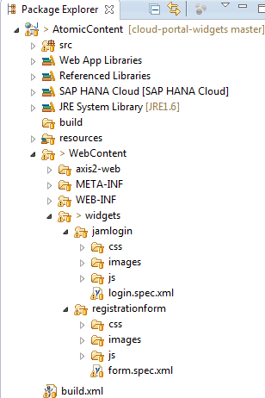

* 1. The **back-end** Java sources are located in the *src* folder. Back-end sources have been provided to enable server-to-server communication between the *Registration Form* widget and a Web service that is exposed by the *Cloud for Customers* back-end system. The Java sources include:
  + A **Service Stub** – which is a Web Service Client generated from the Web service’s WSDL file.
  + A **Servlet** that is triggered by the *Registration Form* front end which invokes the call to the *Cloud for Customers* back-end system to persist the registration information provided by the end user.

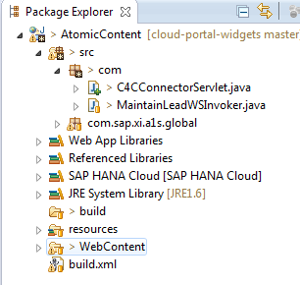

# Exercise 2: Creating Opensocial widgets

In this exercise, you will create OpenSocial widgets using your development environment. The exercise will lead you step-by-step through the development process and explain the different stages of widget creation. Due to time constraints, you will not have to do the actual coding but rather review and understand the code snippets. In addition, you will review the code of three other OpenSocial widgets, which are based on OpenSocial capabilities enhanced and implemented by Cloud Portal.

This part of the exercise shows you how to create a widget. Each widget generally includes (embedded or by reference):

* A JavaScript file, which holds the logic of the widget
* A HTML file, which holds the markup of the widget
* A CSS file, which holds the styling of the widget
* A specification XML (spec XML), which defines the required dependencies and enables the rendering of the widget by Shindig (the OpenSocial container).

By the end of this exercise, the following widgets will be ready for deployment, and located in the *widgets* folder:

|  |  |
| --- | --- |
| Name | Related OpenSocial Feature |
| *Venue List* | Site context (pub-sub) |
| *Venue Map* | Site context (pub-sub) |
| *JAM Logon* | Navigation |
| *JAM Discussions* |  |
| *Registration Form* | Back-end and cloud-to-cloud connectivity |
|  | Widget custom menu item |
|  | Widget preferences |

## Create the widgets for the Venues page

In this section, you will create two widgets: the *Venue List* widget and the *Venue Map* widget, and you will configure the widgets to communicate with each other. To achieve communication between the widgets, you will use the sap-context feature, which is based on the Pub-Sub capability of OpenSocial. The feature works on the principle of publish/subscribe, meaning that widgets publish information to the context (a shared data store) while other widgets subscribe to changes to the context.

In our example, the *Venue List* widget is the ”publisher” (*pub*); it updates the site context with the selected venue location. The *Venue Map* widget is the ”subscriber” (*sub*), which receives the published venue information from the context and displays the venue map accordingly.

After completing the development of this widget the new project structure should look like this:

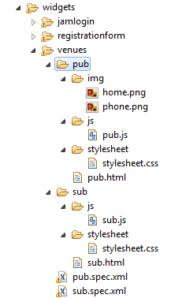

## Create the Venue List widget (the publisher)

* 1. In the Eclipse project, open the following location: widgets.
  2. Create a new folder under widgets and name it venues.
     + 1. Right click on the widgets folder
       2. Select New > Folder
  3. Create a new folder under venues and name it pub.

**Create the JavaScript**

* 1. Create a new folder for java script files under pub and name it **js**
  2. Create a new file (JavaScript file) in the pub/js folder, and name it pub.js.
     + 1. Right click on the js folder
       2. Select New > File
       3. Name it pub.js
  3. Copy the following code into the JavaScript file:

$(".box-a").click(**function**() {

sendReq($(**this**).attr("href"));

**return** **false**;

});

**function** sendReq(row) {

publish("urlSubscriber_contextURL", row);

}

/*

* Used for publishing via sap-context feature

*/

**function** publish(key, val) {

gadgets.sapcontext.publish(key, val);

}

Here, you attach a call to the sendReq function in the *click* event. The sendReq function uses a helper function that publishes a key-value pair to the site context using the gadgets.sapcontext.publish method.   
As soon as the site context is updated with the key-value pair, all subscribed widgets (in this case, the *Venue Map* widget) get the updated context using their callback function (set at the time of subscription).

**Create a new HTML file**

* 1. Create a new file (HTML file) in the pub folder, and name it pub.html.
  2. Insert the following markup into the HMTL file:

1. <html>
2. <head>
3. <link rel=*"stylesheet"* type=*"text/css"* href=*"pub/stylesheet/stylesheet.css"* media=*"all"* />
4. </head>
6. <body>
7. <table id=*"officeTable"*>
8. <tr>
9. <td class=*"details"*>
10. <span class=*"contactDetails"*><strong><a class=*"box-a title"*
11. href=*"https://maps.google.com/maps?f=q&amp;source=s_q&amp;hl=en&amp;geocode=&amp;q=6415+Labeaux+Ave+NE,+Albertville,+MN,+United+States&amp;aq=0&amp;oq=6415+Labeaux+Ave.+*
12. *NE&amp;sll=37.0625,-95.677068&amp;sspn=71.474778,107.138672&amp;ie=UTF8&amp;hq=&amp;hnear=6415+Labeaux+Ave+NE,+Albertville,+*
13. *Minnesota+55301&amp;t=m&amp;ll=45.244739,-93.66643&amp;spn=0.029007,0.054932&amp;z=14&amp;iwloc=A&amp;output=embed"*>
14. Douglas County Events Center</a></strong></span>
15. <br/><div class=*"address"*><img src=*"pub/img/home.png"* class=*"home"*/><span class=*"contactDetails"*>500 Fairgrounds Drive</span></div>
16. <span class=*"contactDetails space"*>Castle Rock, CO 80104</span>
17. <br/><div class=*"phoneDetails"*><img src=*"pub/img/phone.png"* class=*"phone"*/><span class=*"contactDetails"*>(720) 733-6843</span></div>
18. </td>
19. </tr>
20. <tr>
21. <td class=*"details"*>
22. <span class=*"contactDetails"*><strong><a class=*"box-a title"*
23. href=*"https://maps.google.com/maps?f=q&amp;source=s_q&amp;hl=en&amp;geocode=&amp;q=5050+Factory+Shop+Blvd.++Suite+310++Castle+Rock,+*
24. *CO+80108+&amp;aq=&amp;sll=45.244769,-93.666404&amp;sspn=0.007985,0.013078&amp;ie=UTF8&amp;hq=&amp;hnear=5050+Factory+Shops+Blvd+%23310,+*
25. *Castle+Rock,+Colorado+80108&amp;t=m&amp;ll=39.413651,-104.872484&amp;spn=0.031829,0.054932&amp;z=14&amp;iwloc=A&amp;output=embed"*>
26. Pre-Conference Meetings</a></strong></span>
27. <br/><div class=*"address"*><img src=*"pub/img/home.png"* class=*"home"*/><span class=*"contactDetails"*>5050 Factory Shop Blvd.</span></div>
28. <span class=*"contactDetails space"*>Castle Rock, CO 80108</span>
29. <br/><div class=*"phoneDetails"*><img src=*"pub/img/phone.png"* class=*"phone"*/><span class=*"contactDetails"*>(720) 733-6315</span></div>
30. </td>
31. </tr>
32. <tr>
33. <td class=*"details"*>
34. <span class=*"contactDetails"*><strong><a class=*"box-a title"*
35. href=*"https://maps.google.com/maps?f=q&amp;source=s_q&amp;hl=en&amp;geocode=&amp;q=6415+Labeaux+Ave+NE,+Albertville,+MN,+United+States&amp;aq=0&amp;oq=6415+Labeaux+Ave.+*
36. *NE&amp;sll=37.0625,-95.677068&amp;sspn=71.474778,107.138672&amp;ie=UTF8&amp;hq=&amp;hnear=6415+Labeaux+Ave+NE,+Albertville,+*
37. *Minnesota+55301&amp;t=m&amp;ll=45.244739,-93.66643&amp;spn=0.029007,0.054932&amp;z=14&amp;iwloc=A&amp;output=embed"*>
38. Cocktail Party</a></strong></span>
39. <br/><div class=*"address"*><img src=*"pub/img/home.png"* class=*"home"*/><span class=*"contactDetails"*>410 Fairgrounds Road</span></div>
40. <span class=*"contactDetails space"*>Castle Rock, CO 80104</span>
41. <br/><div class=*"phoneDetails"*><img src=*"pub/img/phone.png"* class=*"phone"*/><span class=*"contactDetails"*>(720) 733-6930</span></div>
42. </td>
43. </tr>
44. <tr>
45. <td class=*"details"*>
46. <span class=*"contactDetails"*><strong><a class=*"box-a title"*
47. href=*"https://maps.google.com/maps?f=q&amp;source=s_q&amp;hl=en&amp;geocode=&amp;q=595+Genoa+Way+Castle+Rock,+CO+80109+*
48. *(303)+814-8800&amp;aq=&amp;sll=39.409589,-104.863729&amp;sspn=0.017524,0.026157&amp;ie=UTF8&amp;hq=(303)+814-8800&amp;hnear=595+Genoa+Way,+*
49. *Castle+Rock,+Colorado+80109&amp;t=m&amp;ll=39.411297,-104.868772&amp;spn=0.007958,0.013733&amp;z=16&amp;iwloc=A&amp;output=embed"*>
50. Conference Accommodations</a></strong></span>
51. <br/><div class=*"address"*><img src=*"pub/img/home.png"* class=*"home"*/><span class=*"contactDetails"*>5595 Genoa Way</span></div>
52. <span class=*"contactDetails space"*>Castle Rock, CO 80109</span>
53. <br/><div class=*"phoneDetails"*><img src=*"pub/img/phone.png"* class=*"phone"* /><span class=*"contactDetails"*>(303) 814-8800</span></div>
54. </td>
55. </tr>
56. </table>
57. <script type=*"text/javascript"* src=*"pub/js/pub.js"*></script>
58. </body>
59. </html>

The markup includes the list of venues and references to the pub.js file, and to the CSS file (that you will create in the next step).

**Create a new CSS file**

* 1. Create a new folder under the pub folder and name it stylesheet.
  2. Create a new file (CSS file) in the stylesheet folder, and name it stylesheet.css.
  3. Insert the following code into the CSS file:

1. **html,** **body** {
2. height: *100%*;
3. width: *100%*;
4. margin: *0*;
5. padding: *0*;
6. background-color: *transparent*;
7. overflow: *hidden*;
8. }
9. *.title* {
10. font-size: *16px*;
11. font-family: *Calibri*;
12. color: *#008FCC*;
13. margin-bottom: *10px*;
14. }
16. *.title:visited* {
17. color: *#008FCC*;
18. }
20. *.contactDetails* {
21. font-size: *14px*;
22. font-family: *Calibri*;
23. color: *#333333*;
24. vertical-align: *middle*;
25. }
27. *.address*{
28. padding-top: *10px*;
29. }
31. *.phoneDetails*{
32. padding-top: *10px*;
33. }
35. *.details* {
36. padding-left: *15px*;
37. padding-bottom: *25px*;
38. }
39. *.contactDetails* **strong** **a** {
40. text-decoration: *none*;
41. }
42. *.space*{
43. padding-left: *25px*;
44. }
46. *.phone* {
47. margin-right: *5px*;
48. vertical-align: *middle*;
49. border: *0*;
50. width: *15px*;
51. height: *15px*;
52. }
54. *.home* {
55. margin-right: *5px*;
56. vertical-align: *middle*;
57. border: *0*;
58. width: *15px*;
59. height: *15px*;
60. }
62. *#officeTable* {
63. margin-top: *10px*;
64. }

Add Image Resources

* 1. Create a new folder under the pub folder and name it img [widgets/venues/pub/img].
  2. In the resources folder that you downloaded from GitHub and extracted to your local partner test folder – navigate to /resources/images/venues.
  3. Copy the home.png and phone.png images to include them in your project.
  4. Paste the images into the img folder that you created in Eclipse.

Create the widget’s Spec XML

* 1. Create a new file (XML file) in the venues folder, and name it pub.spec.xml.
  2. Insert the following code into the XML:

1. <?xml version=*"1.0"* encoding=*"UTF-8"*?>
2. <Module>
3. <ModulePrefs title=*"Venue List"*
4. description=*"Venue publisher widget"*
5. height=*"250"*>
6. <Require feature=*"sap-context"*>
7. </Require>
8. </ModulePrefs>
10. <Content href=*"pub/pub.html"* view=*"authoring, consumption, mobile, preview"*></Content>
11. </Module>

**Detailed explanation about spec XML tags:**

The spec.xml file defines the OpenSocial widget and the features it uses.

1. Open the pub.spec.xml file included in the venues folder
2. Notice that the XML contains the following tags:
   * <Module>: Wraps an OpenSocial widget.
   * <ModulePrefs>: Includes widget preferences, such as required features, configuration, and metadata.
   * <Require>: Defines the dependencies of OpenSocial features. To use an OpenSocial feature, add the feature attribute and use the OpenSocial feature name. Shindig injects the relevant JavaScript code to both the widgets and the container.
   * <Content>: Defines the content of the widget (HTML, JavaScript, CSS). If the content is fetched from an external resource, the href attribute specifies the location of the resource. If the content is very short and does not require a separate file, it is possible to include the code inside the <content> tag using a CDATA entry (you will see this later in the exercise).
   * The view attribute inside the <Content> tag specifies the display settings of the content. An OpenSocial widget may have several views, which indicates that the widget is using different views for different UI/applications (for example: view="authoring, consumption, mobile, preview”).

## Create the Venue Map widget (the subscriber)

Create a new folder

* 1. Create a new folder under venues and name it sub.

Create a new JavaScript file

* 1. Create a new folder for your JavaScript files under sub and name it **js.**
  2. Create a new file (JavaScript file) in the sub\js folder, and name it sub.js.
  3. Copy the following code into the JavaScript file:

1. var urlSubscriber = {};
2. urlSubscriber.prefix = "urlSubscriber_"; ///this is a reserved prefix for all keys, to avoid conflicts
3. urlSubscriber.pubsubKey = "contextURL";
4. /*
5. * This will be the callback function of a publish event.
6. */
7. urlSubscriber.getURL = function getURL(topic, context) {
8. urlSubscriber.changeURL(context.getPropertyByKey(urlSubscriber.prefix + urlSubscriber.pubsubKey)[0] + "");
9. };
10. /*
11. * Holds the logic for getting the right Google map according to a given URL.
12. */
13. urlSubscriber.changeURL = function changeURL(link) {
14. if((link !== "") && (typeof link != "undefined") && (link!="undefined") && (link != undefined)) {
15. $("iframe").remove();
16. $("body").prepend('<iframe src="'+link+'"></iframe>');
17. }
18. };

Append the code for using the sap-context feature

* 1. Append the following code to the bottom of sub.js:

1. /*
2. * Subscribe to site context with predefined callback.
3. * Keeps the subscription ID in urlSubscriber.subId variable.
4. */
5. **function** subscribe() {
6. urlSubscriber.subId = gadgets.sapcontext.subscribe(urlSubscriber.getURL);
7. }
8. // Subscribe to site context on widget load
9. gadgets.sapcontext.registerOnContextLoad(subscribe);

The subscribe function calls gadgets.sapcontext.subscribe. This method gets a callback function as a parameter. The callback is invoked when the context is updated.

The subscribe function gets two parameters:

* + Topic: This is always sap-context, to ensure that the widgets are using the sap-context feature to transfer data.
  + Context: The shared site context. You use the Context Object API to get the desired property. For example: getPropertyByKey method in the code snippet above.

You can see how the subscribe function is implemented in the previous code snippet, where urlSubscriber.getURL gets topic and context as parameters.

Create a new HTML file

* 1. Create a new file (HTML file) in the sub folder, and name it sub.html.
  2. Insert the following markup into the HTML:

<html>

<head>

<link rel=*"stylesheet"* type=*"text/css"* href=*"sub/stylesheet/stylesheet.css"* media=*"all"* />

<script type=*"text/javascript"* src=*"sub/js/sub.js"*></script>

</head>

<body>

<iframe id=*"frameInWidget"* src=*"https://maps.google.com/maps?output=embed&t=m&num=1&q=usa"*></iframe>

</body>

</html>

The body of the HTML includes an iframe, pointing to the Google Mapsservice, which displays a map of the USA at start up. When a widget (in this case, the *Venue List* widget) publishes a value under the contextURL key, the value is inserted as the iframe src attribute, and the map is rendered with the location of that value.

Create a new CSS file

* 1. Create a new folder under the sub folder and name it stylesheet
  2. Create a new file under sub\stylesheet and name it stylesheet.css
  3. Insert the following code into the CSS:

1. **body** {
2. width:*100%*;
3. height:*100%*;
4. margin: *0px*;
5. padding: *0px*;
6. }
7. **iframe,** **div** {
8. width:*100%*;
9. height: *100%*;
10. position: *absolute*;
11. top:*0px*;
12. left: *0px*;
13. background-color:*#ccdef6*;
14. border: *none*;
15. }
16. **div** {
17. z-index:*2*;
18. }
19. **iframe**{
20. z-index:*1*;
21. }

Create the spec XML of the widget

* 1. Create a new XML file in the venues folder, and name it sub.spec.xml.
  2. Insert the following code into the XML:

1. <?xml version=*"1.0"* encoding=*"UTF-8"*?>
2. <Module>
3. <ModulePrefs title=*"Venue Map"*>
4. <Require feature=*"sap-context"*/>
5. </ModulePrefs>
6. <Content href=*'sub/sub.html'* view=*"authoring, consumption, mobile, preview"*></Content>
7. </Module>

**In the runtime site, the Venue widgets will look like this:**

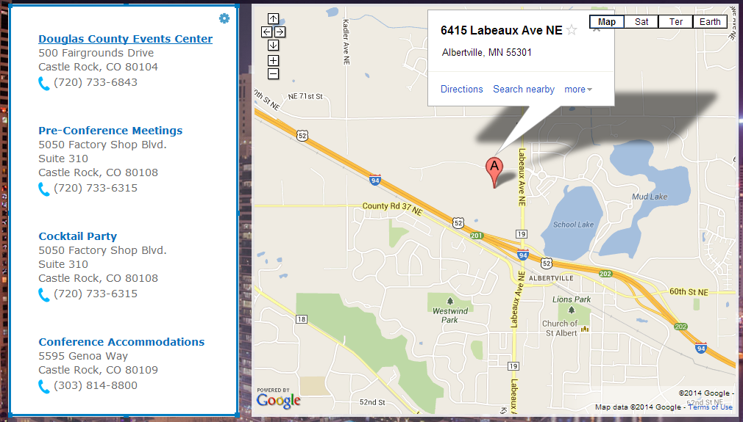

## Review the *Registration Form* widget

Cloud Portal enables connectivity to SAP back-end systems, using the HANA Cloud Destination. This widget includes a simple SAPUI5 form with a *Register* button that persists the registered data in two optional target systems - either a SAP CRM back end System or a Cloud based ‘Cloud for Customers’ system (C4C – formally known as *ByDesign*).

* The *SAP CRM back-end system* – is a CRM system persisting registration data in a dedicated table using an exposed service called by a gateway system. The service is invoked by a REST call from the widgets front-end. The Gateway server and the CRM system are both internal SAP system and therefore require a **destination** in order to allow connecting from the trial system which is external
* The *Cloud for Customers System (C4C)* – Is an external cloud based system allowing interaction with other external systems through various exposed Web Services. In this widget we invoke a specific web service that updates an existing table with the registration data. Since both the trial landscape and the C4C system are public there is no need for a destination to enable the connection between the two.

The widget contains an initial settings screen prompting the site author to choose the back end connectivity target. The settings screen is also available through a dedicated menu option. After the initial configuration is completed the form is ready to be used by end users. In runtime, when the end user clicks *Register*, a new entry is added to the configured target system.

The *Registration Form* widget provides an example of widget contents (HTML, JS, CSS) placed inside the widget spec XML, using the CDATA entry.

**Open the spec XML of the Registration Form widget**

* 1. Open the spec XML of the *Registration Form* widget, located at widgets/registrationform/form.spec.xml.
  2. Inspect the CDATA entry:

1. <?xml version=*"1.0"* encoding=*"UTF-8"*?>
2. <Module>
3. <ModulePrefs title=*"Registration Form"*>
5. <Require feature=*"sap-menu"*/>
6. <Require feature=*"gadgetprefs"*/>
7. </ModulePrefs>
9. <UserPref name=*"targetSystem"* default_value=*"select"*/>
10. <Content type=*"html"* view=*"default, authoring, consumption, mobile, preview"*>
11. <![CDATA[
12. <!DOCTYPE HTML>
13. <html>
14. <head>
15. <script src="https://sapui5.netweaver.ondemand.com/resources/sap-ui-core.js"
16. type="text/javascript"
17. id="sap-ui-bootstrap"
18. data-sap-ui-libs="sap.m,sap.ui.commons"
19. >
20. </script>
22. <link type="text/css" rel="stylesheet" href="css/form.css"/>
23. <script type="text/javascript" src="js/form.js"></script>
24. <script type="text/javascript">
25. gadgets.util.registerOnLoadHandler(loadViews);
26. </script>
27. </head>
28. <body id="body" class="sapUiBody">

31. <div id="formRuntimeDiv">
32. <div id="headerDiv">
33. <img style="height: 27px; width: 27px;" alt="" src="images/register.png"/>
34. <span class="title">Registration</span>
35. <br/><span class="subtitle">Registration closes on July 10, 2014</span>
36. <br/><span class="subsubtitle">Fill in the form and we will contact you to finalize your registration.</span>
37. </div>
38. <div id="formBodyID" class="formBody">
39. <div id="emf-error-msg" class="right emf-error-message">
40. <span id="error-msg"></span>
41. </div>
42. <div id="oDialog"></div>
43. </div>
45. <div id="formSettingsDiv" class="formSettings">
46. </div>
48. <div id="formSuccessDiv" class="formSuccess">
49. <div id="emf-success-msg" class="right emf-success-message">
50. <span class="success-msg"></span>
51. </div>
52. </div>
54. </div>
56. </body>
57. </html> ]]>
58. </Content>
59. </Module>

In this example, the type attribute is inside the <content> tag. To embed the HTML code of the widget inside the spec XML, use type='html' and write the HTML code in the CDATA tag. This replaces the href attribute with a path to the HTML file (as shown in the spec XML of the *Venues* widgets).

Notice that we use several OpenSocial features here by adding the Require tag.

* + **sap-menu**: allows adding a custom menu option available to the site author in the authoring environment. Open the widgets javascript available under widgets/registrationform/js/form.js. The code snippet shows how we add a new menu item to the existing default menu and set a callback method to be invoked once the menu option is selected.

//add menu option

gadgets.sap.menu.addMenuItem({

ID:'properties',

menuID:gadgets.sap.menu.DEFAULT_MENU_ID,

text:"Select System",

separator:**true**,

callback: editFeedMenuItemCallback

});

The feature also supports the creation of additional new menus.

* + **Widget properties**: You can set a default value for widget properties in the *<UserPref>* section of the spec XML. This capability is provided by the OpenSocial ***setprefs*** core API and is available for use without any further action.

<UserPref name=*"targetSystem"* default_value=*"select"*/>

To allow site authors to change a default value in the authoring mode, and to set a customized value for all site users, we require the Cloud Portal *gadgetprefs* feature in the spec XML.

**var** prefs = **new** gadgets.GadgetPrefs();

//Setting a value

**var** selectedTargetSystem = oFeedTypeDropDownBox.getSelectedKey();

prefs.setPreference("targetSystem",selectedTargetSystem);

//Getting a value

**var** targetSystem = prefs.getPreference("targetSystem");

* + **SAPUI5:** The *Registration Form* widget UI is developed using SAPUI5. In order to use the latest version of the SAPUI5 library. The sap-ui-bootstrap ID is used to load the latest version of the SAPUI5 library from the Cloud Portal servers, as follows:

<script id="sap-ui-bootstrap"

type="text/javascript"

src="https://sapui5.hana.ondemand.com/resources/sap-ui-core.js"

data-sap-ui-theme="sap_goldreflection"

data-sap-ui-libs="sap.ui.commons">

</script>

About the HTTP destination

At the beginning of this exercise you deployed two destination files to your account. Cloud Portal uses HANA Cloud HTTP Destination to point to a back-end system. Destinations are deployed to the Cloud Portal landscape, and contain the information about the destination system (hostname, port, authentication type, and so on.).

To use the HANA Cloud HTTP Destination, the URL pointing to the back-end service should have the following format: http://dest.<destination_name>/<path_to_service>

* destination_name: The name of the destination, as configured in the destination properties file.
* path_to_service: The path to the back-end service, as in the JavaScript code.

**NOTES:**

* When using a destination on a public page, the destination name must have a __public (two underscores) suffix. This is required for permission purposes.
* Due to certain limitations of this exercise, the implementation of the destination has changed. Instead of having a destination deployed automatically to each of the accounts, a proxy application has been defined for using the destination to the back-end system. The correct URL for a production environment in this case would be:

**var** url = 'http://dest.crm__public/sap/opu/odata/sap/ZDEMO_LEAD_SRV/Leads

**Open the JavaScript of the *Registration Form* widget**

* 1. Open the JavaScript file of the *Registration Form* widget, located at widgets\registrationform\js\form.js
  2. Scroll down through the code and inspect the formSubmitAjaxToCRM function:

1. /*
2. * Execute ajax request to backend system using makeRequest
3. */
4. **function** formSubmitAjax() {
5. **var** url = 'http://dest.crm__public/connectivity.proxy/proxy/crm/sap/opu/odata/sap/ZDEMO_LEAD_SRV/Leads';
6. **var** postdata = composePostPayloadJSON();
7. **var** params = {};
9. **var** postdataStr = JSON.stringify(postdata);
11. params[gadgets.io.RequestParameters.POST_DATA] = postdataStr;
12. params[gadgets.io.RequestParameters.METHOD] = gadgets.io.MethodType.POST;
13. **var** callback = **function** ajaxCallback(result) {
14. **if** (result['rc'] === 201) {
15. showFormSuccess();
16. } **else** {
17. showFormError("Could not connect to CRM system.");
18. }
19. };

In this example, we use gadgets.io.makeRequest, which is the standard API for requesting another server from within a widget, thereby allowing cross-domain calls.

* 1. Inspect the formSubmitAjaxToC4C function:

1. 

In this example we perform an Ajax call from the applications front end to the Java back end. The call invokes a Java servlet, which then handles the call to the C4C system using a dedicated Web service client. We use gadgets.io.getProxyUrl to calculate the URL to be invoked from the widget that runs within the *Cloud Portal* application to the servlet contained in the *AtomicContent* application.

## Review the JAM Login widget

Cloud Portal allows several integration points between widgets and site parts. Using the sap-navigation OpenSocial feature, it is possible to define navigation from one page to another page in the site. The target page may be visible or hidden, and public, restricted, or private.

In this part of the exercise, you will inspect the code of the *Jam Login* widget that after login invokes the navigation API linking to the *JAM Discussions* page.

Open the spec XML of the Jam Login widget

* 1. Open the spec XML of the *Jam Login* widget, located at widgets/jamlogin/login.spec.xml.

1. <?xml version=*"1.0"* encoding=*"UTF-8"*?>
2. <Module>
3. <ModulePrefs title=*"JAM Login"*>
4. <Require feature=*"core.prefs"*/>
5. <Require feature=*"gadgetprefs"*/>
6. <Require feature=*"sap-navigation"*>
7. <Param name=*"outport"*>
8. {
9. "ID": 1,
10. "target": "JAM"
11. }
12. </Param>
13. </Require>
14. </ModulePrefs>
15. <Content type=*"html"* view=*"default, authoring, consumption, mobile, preview"*>
16. <![CDATA[
17. <link rel="stylesheet" type="text/css" href="style.css">
18. <script type="text/javascript" src="login.js"></script>
19. ]]>
20. </Content>
21. <Content type=*"html"* view=*"default, authoring, consumption, mobile, preview"*>
22. <![CDATA[
23. <div id="container"></div>
24. ]]>
25. </Content>
26. </Module>

In the <Require> tag, note the dependency to the sap-navigation feature. Also note the outport parameter inside the <Require> tag. It is possible to pass to the feature one or more outport parameters, which define the navigation targets for that widget. The outport parameter has two properties: a unique ID, and the alias of the target page. You define the page alias in the *Page Management* panel of the Authoring Space. You will use the page alias later in the tutorial.

Open the JavaScript file of the *Jam Login* widget

* 1. Open the JavaScript of the *Jam Login* widget, located at widgets/jamlogin/js/login.js.

1. **var** tempText = "Click to join JAM discussions";
2. **this**.$content.addClass('welcome').bind("click", **function**() {
3. gadgets.sap.navigation.navigate(1);
4. });

The JavaScript of the *Jam Login* widget holds the navigation information, according to the outport configuration in the spec XML. The JavaScript includes a callback function on a button.click event. The callback function calls the gadgets.sap.navigation.navigate with the relevant outport ID (1 in this case). In the spec XML, the target of outport ID =1 is the *JAM Discussion* page.

# Exercise 3: Adding the widgets to cloud portal

In this exercise, you will deploy the OpenSocial widgets that you created to HANA Cloud. Thanks to the auto-discovery feature, all OpenSocial widgets deployed to the Cloud Portal are automatically discovered and created as widgets available for use in the Content Catalog with the title, description and icon as configured in your deployed war file. As a Cloud Portal administrator, you can also manually create the widgets in the Cloud Portal, in the *CONTENT* tab.

## Deploy the widgets to HANA Cloud

Open the New Server wizard

* 1. In the Eclipse Package Explorer, select the AtomicContent project.
  2. Right-click and click *Run As > Run on Server*.
  3. The *Run On Server* wizard opens.

Create a new server

* 1. Select *Manually define a new server*.

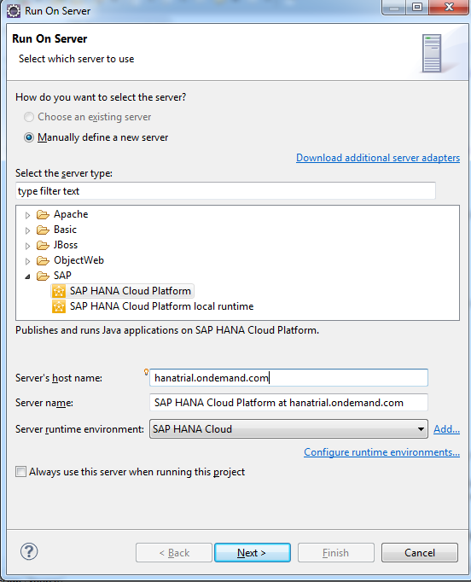

* 1. From the *Select the server type* list, select SAP > SAP HANA Cloud Platform
  2. Set the following options:
  + *Server's host name*: hanatrial.ondemand.com
  + *Server name*: Keep the default
  + *Server runtime environment*: SAP HANA Cloud (this is the default)
  1. Click *Next*.

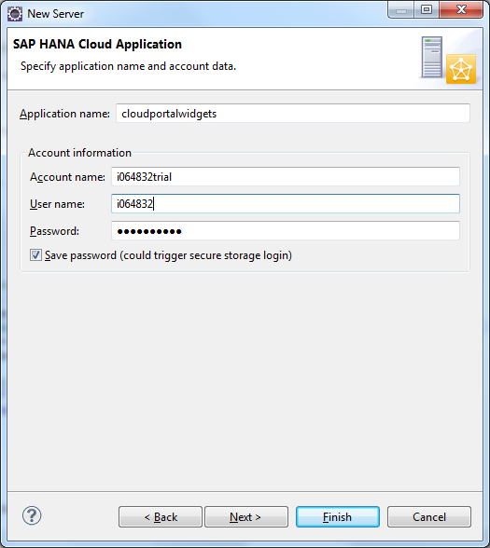

* 1. Set the following options:
  + *Application name*: **atomiccontent** (**use lower case only**)
  + *Account name*: <*SCN user ID*>trial; for example, i099999trial
  + *User name* and *Password*: Your assigned SCN username and password; for example, i099999 and Abcd1234
  1. Click *Next*.

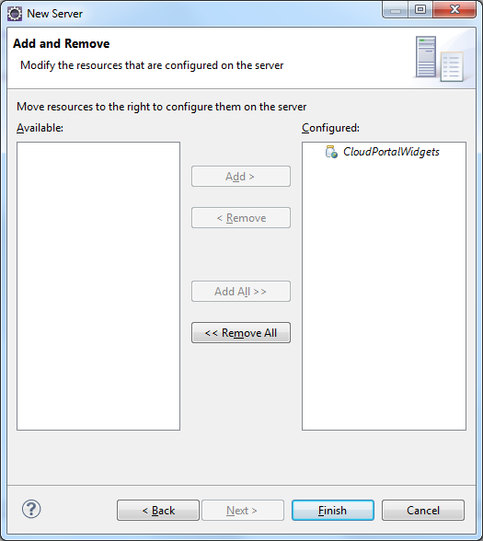

* 1. Move AtomicContent to the *Configured* list if it is not there.
  2. Click *Finish*.  
     If you receive a notification, click *No*.
  3. In the lower right corner of the Eclipse window, a progress bar of the application deployment is displayed. Deployment may take a few minutes.
  4. **When deployment is complete, you may receive an HTTP Status 404error message, you can ignore this message.**

Test the URLs to the widget files

* 1. In the browser window, enter the URL for the *Venue List* widget:  
     https://atomiccontent<*account*>.hanatrial.ondemand.com/AtomicContent/widgets/venues/pub.spec.xml  
     (Replace <*account*> with your trial account name)
  2. Verify that the expected widget XML file opens.
  3. If the XML is available, the project has been deployed successfully and the widgets are ready to be used.

## Add the widgets to Cloud Portal with auto-discovery

After the project that we developed is deployed as a WAR file to the SAP HANA Cloud trial platform, the corresponding widgets are created in the Content Catalog of Cloud Portal by means of an auto-discovery mechanism. This is accomplished by identifying all OpenSocial spec.xml files that follow a specific naming convention: **<file name>.spec.xml.**

Along with auto-discovery, it is also possible to define the widget title, enter a description of the widget, and add dedicated icon, as you can see in the *Venues Map* spec xml file name **sub.spec.xml**:

<?xml version=*"1.0"* encoding=*"UTF-8"*?>

<Module>

<ModulePrefs title=*"* *Venues Map"* description*="Google Maps Subscriber"* thumbnail*="https://lh4.googleusercontent.com/-2UJ8CLscXyI/AAAAAAAAAAI/AAAAAAAAAAA/Ss1x5u-BI_8/s48-c-k/photo.jpg"*>

<Require feature=*"sap-context"*/>

</ModulePrefs>

<Content href=*'content/sub/sub.html'* view=*"authoring, consumption, mobile, preview"*></Content>

</Module>

View the widgets in Cloud Portal

* 1. Open the browser and go to your trial account.
  2. Navigate to the *CONTENT* tab. After deployment, our widgets are available in the *Content* tab of the authoring environment (under the category Auto-discovered).

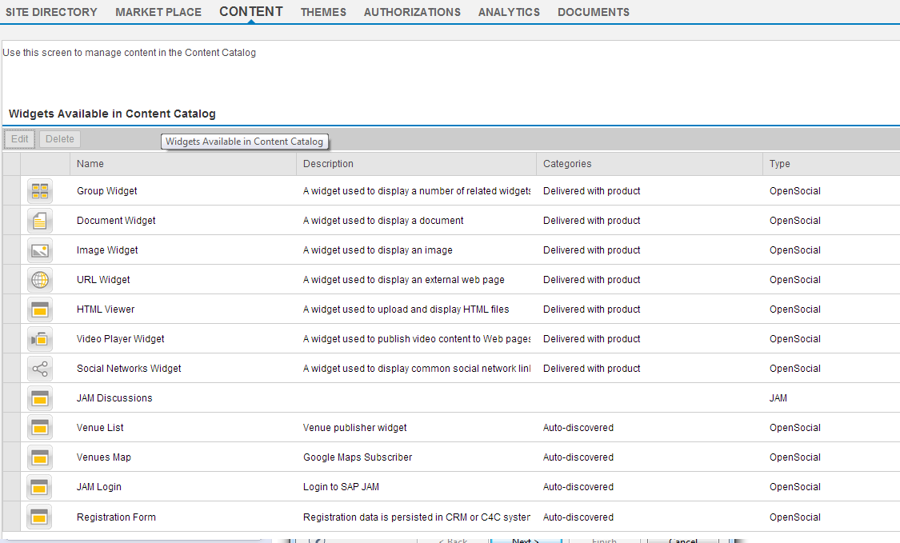

The *Generic Widgets* screen lists the content that will be available in the Content Catalog for site creators and authors when they built sites in the Authoring Space of Cloud Portal.

## Manually create widgets for use in Cloud Portal

It is also possible to manually create widgets for import into the Content Catalog. For example, we could manually create the *Venue List* widget as follows:

# Exercise 4: creating and configuring a new cloud portal site

In this exercise, you will import one of the sites available in the Cloud Portal Market Place. You will use your trial account to perform Cloud Portal site authoring and configuration.

## Manage content in the Content Catalog

* 1. Click the *CONTENT* tab above the Site Directory. All widgets available in the Content Catalog are displayed.
  2. Click *+ Add Widget*. The *Add Widget* dialog box opens.
  3. Set the following parameters:
  + *Type*: Jam Feed
  + *Name*: Jam Discussions
  + *Description*: <free text>
  + *Jam Server*: [www.cubetree.com](http://www.cubetree.com)
  + *Company Domain*: sap.com
  1. Click *Save*.

A new Jam Feed widget is configured and available as part of your Content Catalog.

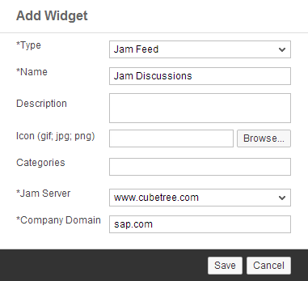

## Manage files in the Document Repository

* 1. Click the *DOCUMENTS* tab.
  2. Refresh the page (F5) in case your session timed out.
  3. To create a new folder, click the  (New folder) toolbar button, change the folder name to *Assets*, and press Enter.
  4. Click the *Assets* folder to open it and create a subfolder.
  5. Click the  (New folder) toolbar button again, and name the new folder *Atomic*.
  6. To upload a file to the folder, click the  (Upload file to the repository) toolbar button and in the Open dialog box, browse to the venues-header.html file under *HTML sources* folder created on your local system (C:\pt2014\cloud-portal-widgets-master\resources\HTML sources). A notification message is displayed when the file is successfully uploaded.
  7. Repeat the same step to upload jam-header.html and sap-image.png (C:\pt2014\cloud-portal-widgets-master\resources\Images) files.  
       
     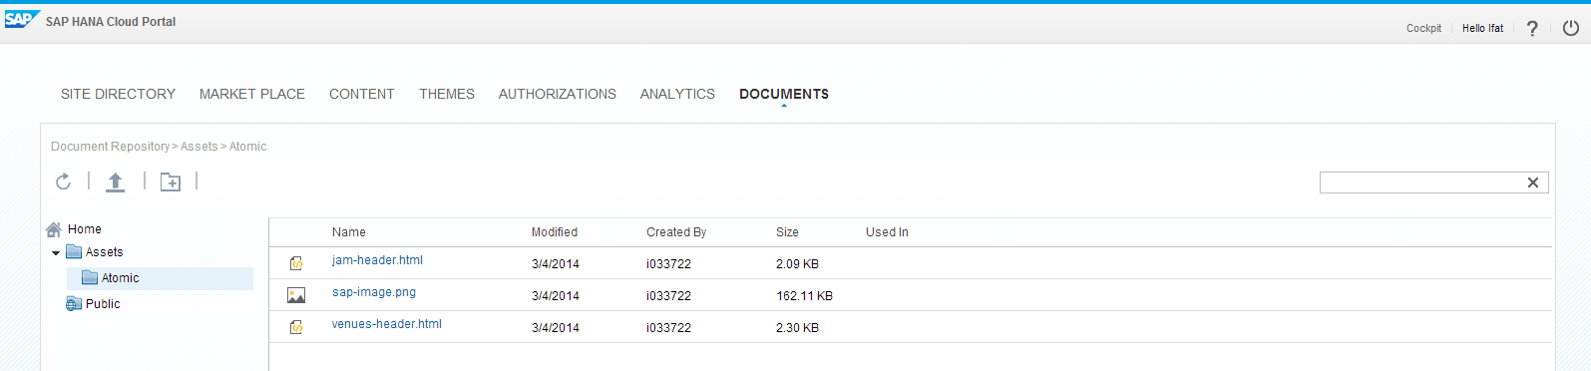
  8. In the folders tree at the left, click the *Public* folder, which contains files used in this site, as well as other files that can be publically shared by getting their URL from the repository.
  9. Click on the  (Upload file to the repository) toolbar button again, and browse to the following image file:  
     Site-logo.png
  10. Repeat the previous step to upload the Site-background.png image from the same folder.
  11. Navigate back to the *Home* folder using the breadcrumbs.
  12. In the Search box at the top, type Site-background. The file is displayed in the search results.  
        
      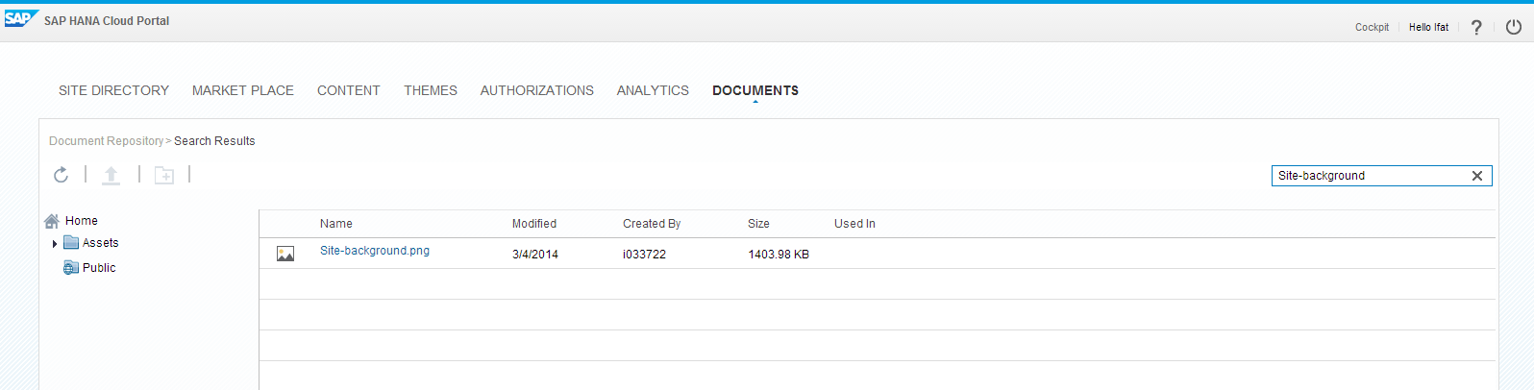

## Import a site from the Cloud Portal Market Place

* 1. Click the *MARKET PLACE* tab. All sites available in the Market Place are displayed:

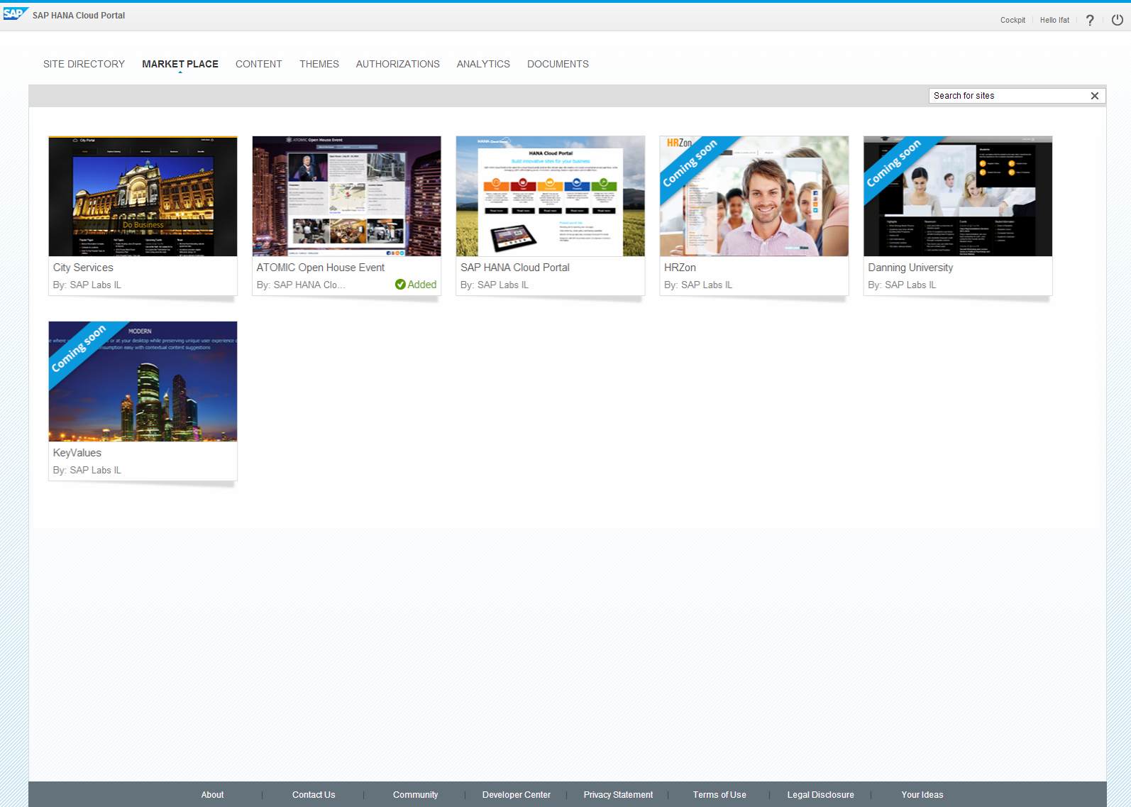

* 1. Hover over the *ATOMIC Open House Event* site card.

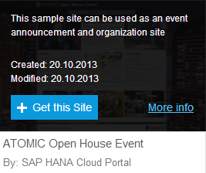

* 1. Click *More info* to get detailed information about this site.
  2. Click + *Get this Site* to import the *ATOMIC* site to your trial account. A notification message is displayed when the site has been added to your Site Directory.
  3. Click the *SITE DIRECTORY* tab to view your available sites. You will see the following new site card:

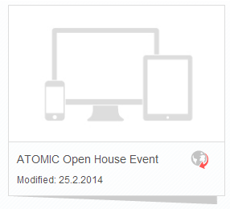

* 1. Hover the *ATOMIC Open House Event* site and click *Edit* to open the site for editing.

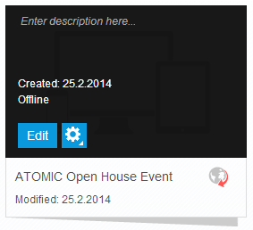

## Configure site design settings

* 1. From the side-panel menu, click  (Design Settings). The *Design Settings* panel opens.
  2. To use a grid for your page layout, click the 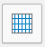 (Show/Hide grid) toggle button in the *Help Lines* field.   
     The grid is overlaid on the page.
  3. Click the *Show more* link to change the site layout at a fine granularity, as follows:
  + Keep the *Site Width* at 1024 pixels for a better layout experience.
  + Using the *Minimum Space Between Widgets* slider or text box, set the gap between widgets to **0** pixels (if specified otherwise).

# Exercise 5: Managing Pages and Content in Your Site

In this exercise, you will learn how to remove, add and manage templates by applying page management capabilities. You will add content to the new pages to expose the applications deployed to your account in SAP HANA Cloud platform.

## Delete a page

* 1. From the side-panel menu, click  (Page Management). The *Page Management* panel opens.
  2. Select the *Agenda* page, click the (Delete) icon and click *Yes* in the confirmation dialog box.
  3. Repeat the step to delete the *Accommodations* page.

## Add new pages to the site

* 1. In the *Page Management* panel click + Add Page
  2. Click on the page name, change the name to Venues and press Enter.
  3. Click the (Page settings) icon. More page parameters are displayed.
  4. Enter a *Page Alias* by providing a name that serves as an identifier of that page. A valid page alias name must contain only alphanumeric characters, hyphens or underscores, with no spaces.
  5. Note that the page *Access Level* is set to ***Public*** by default, taken from the site access level definition.
  6. From the *Page Template* dropdown list, select ***Atomic template***.
  7. Click + *Add Page* to add another page:
     + 1. Name the new page Jam Discussions and press Enter.
       2. For Page Alias, enter JAM, which is same identifier used for the navigation API in the Jam Login widget.
       3. Set the *Access Level* to be *Restricted*. Only authenticated users will be able to access this page.
       4. Select the *Standard* from the list of available page templates.

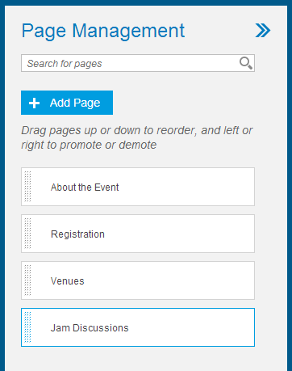

## Add content to the *Venues* page

* 1. Click the *Venues* page in the page navigation bar, and from the side-panel menu, click  to open the Content Catalog.
  2. In the Search field at the top, type Venue List.
  3. Drag the widget to the left side of the page content area, as shown in the following illustration.
  4. Search for the Venue Map widget in the Content Catalog and drag it to the right of the Venue List widget.
  5. Similarly, drag the *HTML Viewer* (out-of–the-box widget) from the Content Catalog and place it above the *Venue List* and *Venues Map* widgets.
  6. Click *Select from Repository*, and select the venues-header.html file  
       
     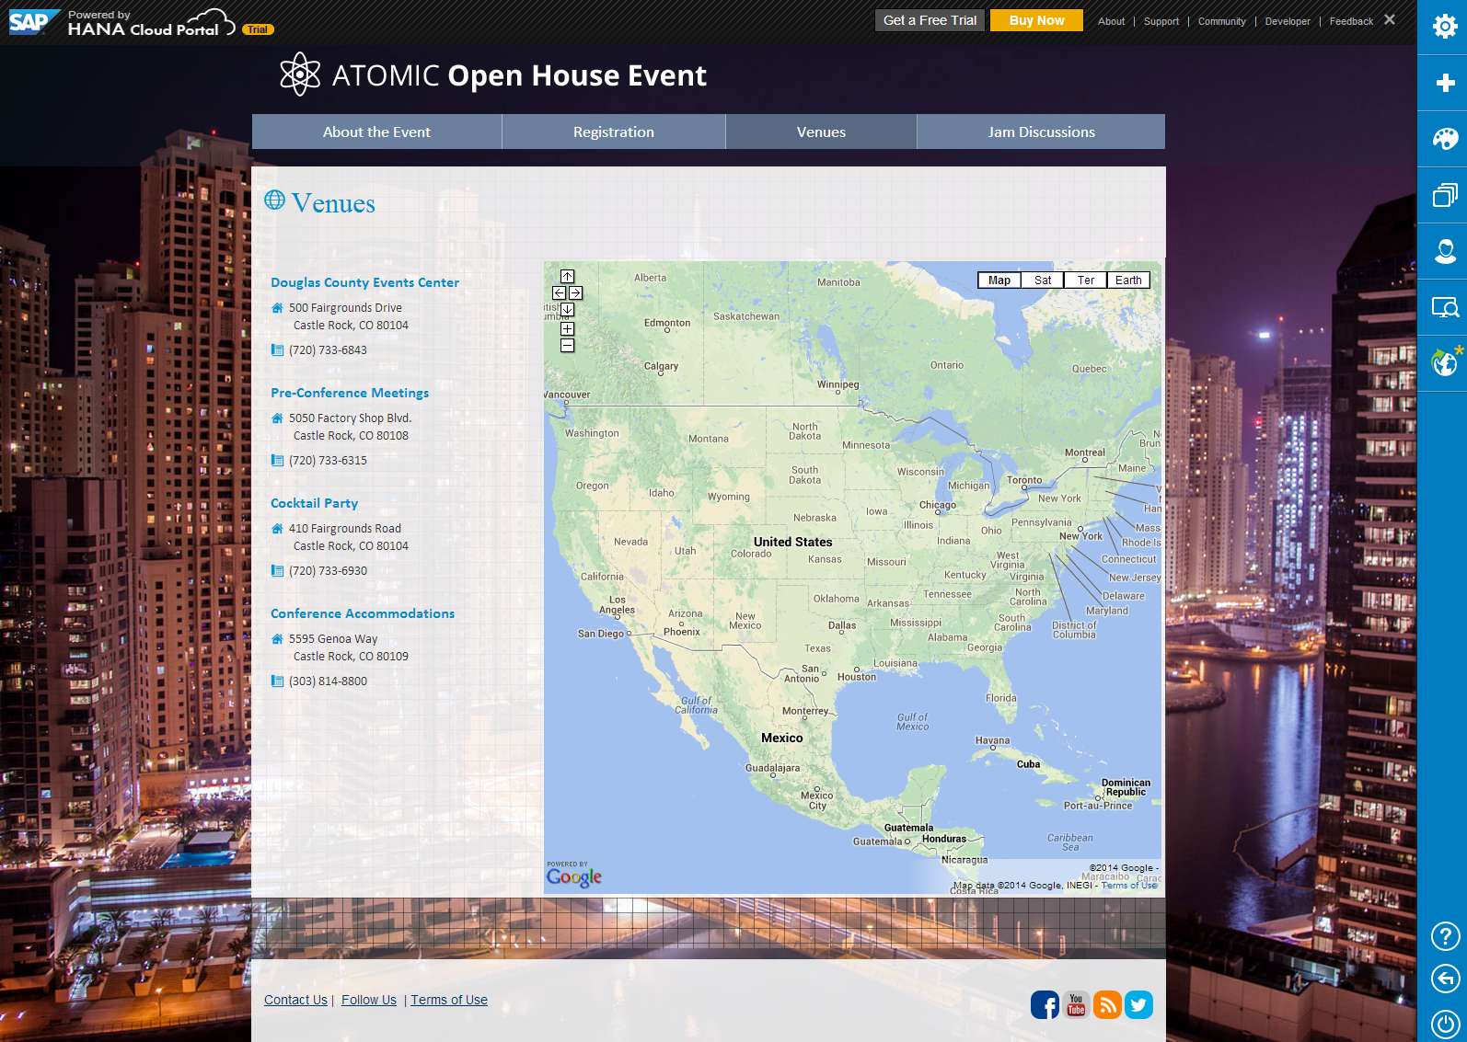

## Add content to the Jam Discussions page

* 1. Click the *Jam Discussions* page in the page navigation bar, and from the side-panel menu, click  to open the Content Catalog.
  2. In the Search field at the top, type Jam Discussions.
  3. Drag the widget to the page.
  4. Configure the *Jam Discussions* widget to display group discussions:
  + *Feed Type*: ***Group Feed***
  + *Group ID*: 571543
  1. Click *Confirm*. The *Jam Feed* widget is rendered.
  2. Drag the *HTML Viewer* widget from the Content Catalog to the page, placing it on top of the *Jam Discussions* widget.
  3. Click *Select from Repository*, select the jam-header.html file.
  4. Drag an Image widget form the Content Catalog to the page, placing it on the right to the Jam Discussions.
  5. Click *Select from* *Repository*, select the sap-image.png file.

## Customize the Jam Discussionspage header and footer

Every page in a site can be assigned to a template, which determines the layout and the page elements such as header, footer and side panels. You can modify the *Short header* page templateto achieve a custom page layout.

* 1. Hover over the *Site Name* in the page header.
  2. In the (Widget options) menu, click *Edit*.
  3. Delete the site name and click *Save and Close.*
  4. Hover over the site logo in the page header, and from the (Widget options) menu, click *Edit*.
  5. Click *Select from Repository*, and select the Site-logo.png file from the Public folder
  6. Edit the *Page Navigation Menu,* and from the *Alignment* dropdown list, click *Stretch.* Then click *OK.*
  7. In the page footer, edit the *Social Networks* widget in the page footer as follows:
     + 1. Click *+Add Links* and select the *YouTube* icon from the displayed icon list.
       2. To the right of the added icon, enter the following URL: <https://www.youtube.com/playlist?list=PLFD0FA2183DC1F3B7>
       3. Set Icon Size to Small.
       4. Align icons to the right side of the widget.
       5. Click *OK*. The YouTube icon is added to the footer.

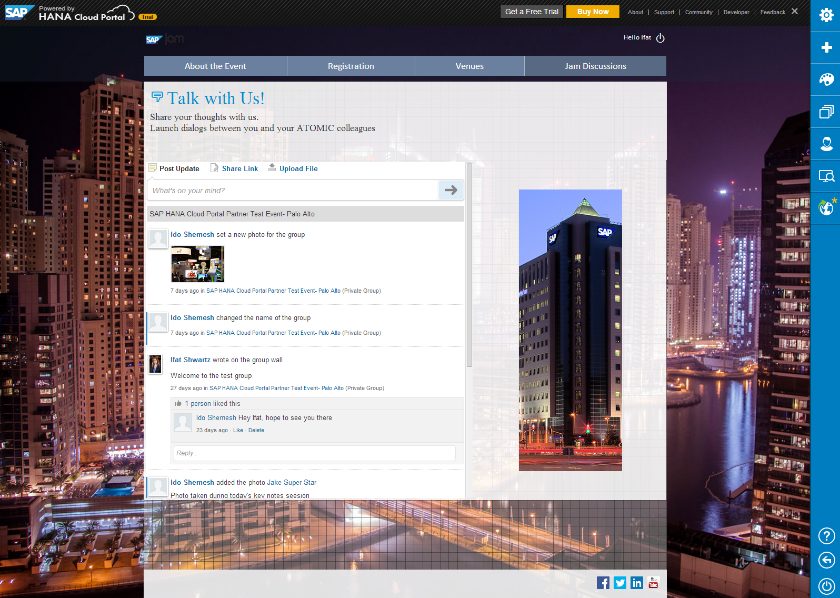

## Update the About the Event page

* 1. Hover over the top-right image widget, and in the (Widget options) menu, click *Remove*.

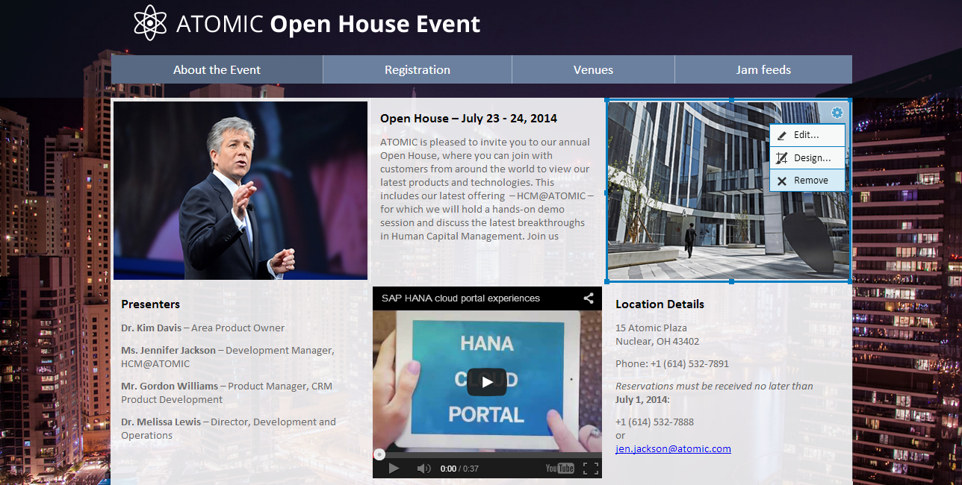

* 1. From the side-panel menu, click  to open the Content Catalog.
  2. In the Search field at the top, type Jam Login.
  3. Drag the widget to the page to replace the image widget.

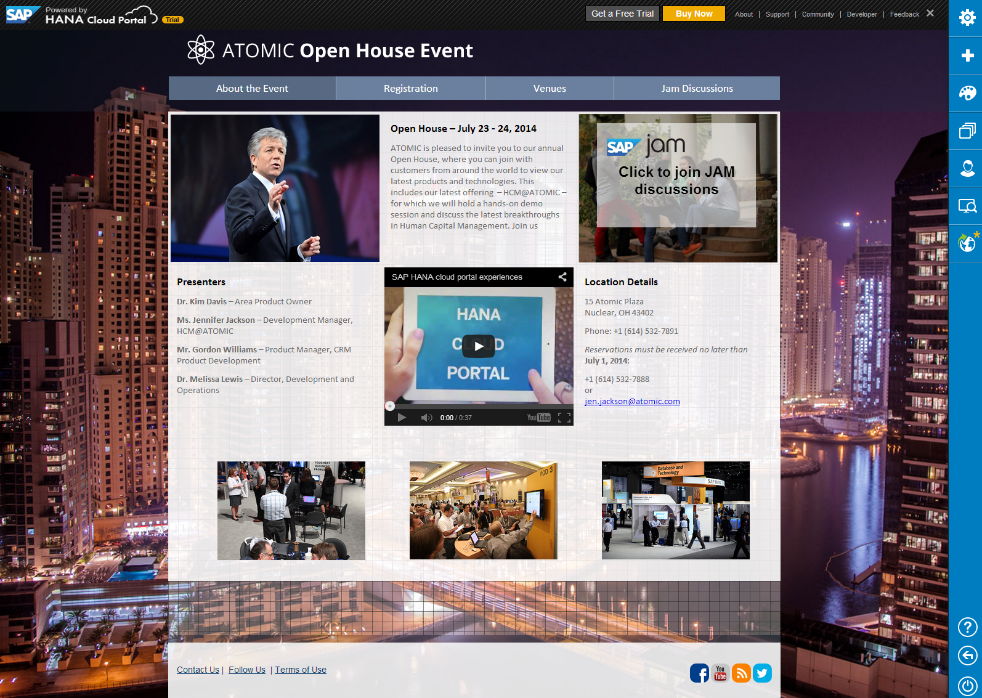

## Update the Registration page

* 1. Click the *Registration* page in the page navigation bar.
  2. Remove the existing *Registration Form* and *Upcoming Events* widgets using the (Widget options) menu.
  3. Open the Content Catalog and find the *Registration Form* widget.
  4. Drag the widget to the page.
  5. Select C4C to connect the form to Cloud CRM, or CRM on-premise. The registrations will be saved as leads in the CRM backend systems per your selection.
  6. Resize the widget to fit the page content area.  
       
       
     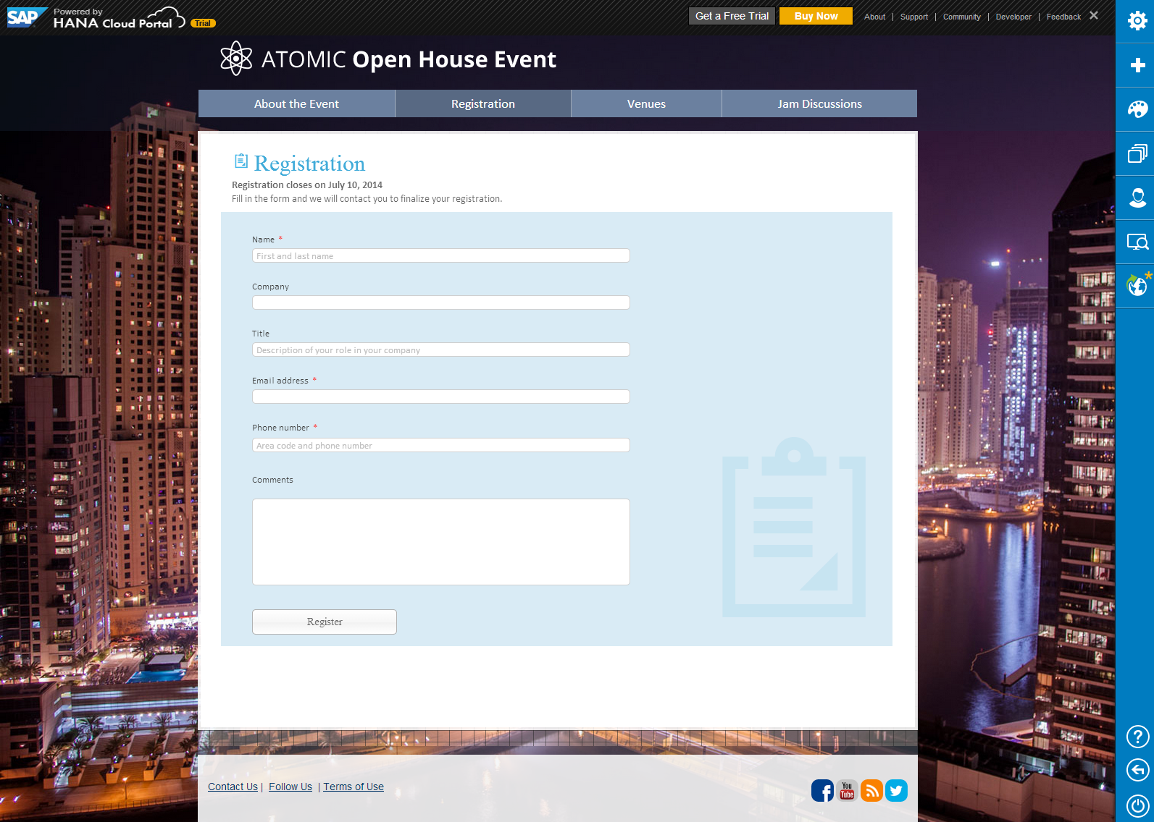

## Remove the page grid

* 1. From the side-panel menu, click  (Design Settings). The *Design Settings* panel opens.
  2. In the *Help Lines* field, click the 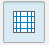 (Show grid) toggle button. The grid is removed from the site pages.

# Exercise 6: ENHANCING THE site layout and theme

Using the default theme provided by SAP HANA Cloud Portal, you can create a new theme based on your company’s branding and site-design requirements. Cloud Portal supports LESS as the stylesheet for site theming.

## Customize the site background and page navigation bar

Download the theme

* 1. Click the *THEMES* tab above the Site Directory. You use this screen to manage the themes that will be available to your site creators and authors.
  2. Select the *Cloud Portal Event Theme* (formal), and click *Download* at the top of the table. The file for that theme is downloaded.
  3. Rename the file to event_new.less.
  4. Open the saved file in Notepad++.

Edit the general settings of the site

**NOTE**: In the following sections, use the Copy and Paste functions to add the code snippets to your LESS file. Also, use Search (Ctrl+F) as needed.

* 1. Change the font style of the site to *Verdana*. Search for @SiteFontFamily LESS parameter and replace with the following code:

1. /*
2. List of fonts you would like to use in the site. Put the font you prefer in the top of the list.
3. If the browser does not support the first font, it tries the next font in the list.
4. */
5. @SiteFontFamily: verdana;

**NOTE**: The @SiteFontFamily parameter also affects the page navigation bar style. This is a calculated parameter.

* 1. Change the site background image as follows:
     + 1. Search for the @SiteBackgroundImage LESS parameter, and remove the value of the URL.
       2. Go back to Cloud Portal. Click the *DOCUMENTS* tab. Navigate to the *Public* folder and search for the background image that you have already uploaded. Hover over *Share Link* and copy the path (URL) of the link.
       3. Paste the URL in the brackets.

After the changes, the settings should look as follows:

/*

Site background image.

To change the default image, provide a URL or a data URI of the image.

*/

@SiteBackgroundImage: url(‘https://cloudportaltrial-<trial account>.hanatrial.ondemand.com/portal/v1/contentRepository/Public/site-background.png');

Edit the page navigation bar settings

* 1. Search for the @PageNavigationBarBackgroundColor LESS parameter that affects the background color of the page navigation bar and change its value:

1. /*
2. Background color of top menu level.
3. Enter color name in text or hex format.
4. This is a mandatory parameter; do not delete and do not leave empty.
5. */
6. @PageNavigationBarBackgroundColor: #008FCC;
   1. Add the @PageNavigationBarTopLevelBackgroundColor parameter, as follows:
7. /*
8. Background color of top menu level.
9. Enter color name in text or hex format.
10. This is a mandatory parameter; do not delete and do not leave empty.
11. */
12. @PageNavigationBarBackgroundColor: #008FCC;
13. @PageNavigationBarTopLevelBackgroundColor: #008FCC;

Upload the new theme and apply it to the site

* 1. Back in the *THEMES* tab of Cloud Portal, click *Add Theme*. The *Add Theme* dialog box opens.
  2. Enter the following information:
  + *Name*: Cloud Portal New Event Theme
  + *Description*: <free text>
  + *Theme Creat*or: <your name>
  + *LESS File*: the event_new.less file that you edited in the previous steps.
  1. Click *Add*. The new theme is added to the *Available Themes* table.
  2. Go back to the Site Directory, open your site for editing, and in the *Design Settings* panel, apply the theme to your site.

# Exercise 7: previewing the site and publishing it

In this exercise, you will learn how to preview your site on a desktop, tablet, or smartphone, and then publish it to your clients. Once the site is published, you will be able to view the site in consumption mode and access it with your mobile device.

## Preview the site

When your site is ready, you can preview it as it will appear on different devices.

* 1. In the side-panel menu, click  (Site Preview).
  2. In the *Preview* *Site* panel, click one of the icons to preview your site on desktop, tablet, or smartphone. A fully functional preview of the site, as it will appear on the selected device, is displayed.
  3. Close the *Site* *Preview* panel.

Publish the site and edit the site URL

* 1. From the side-panel menu, click  (Publishing Options - Offline).
  2. Click *Publish* and then click *Publish* again in the confirmation dialog box. A notification dialog box opens, allowing you to access the site or scan its QR code.
  3. Close the dialog box.
  4. Open the *Site Settings* panel, and in the *Site URL* section, click the URL. The editable part of the URL is displayed in a text box.
  5. Type **Event** and press Enter. The name shortens the URL and makes it meaningful.

View the site in consumption mode

* 1. Open the *Publishing Options* panel.
  2. Click the *Published Site* link in the middle of the panel. A new browser tab opens, displaying the end-user site.
  3. To explore the page restriction mechanism, open a new browse using *new incognito window* option.
  4. The site presents three pages only. Jam Discussion page will be visible only when you will enter your trial credentials in the Jam Login widget.

Access the site with your mobile device

* 1. Return to the Authoring Space and open the *Publishing Options* panel.
  2. Click the *QR Code* link to generate the code, and then scan it with your iPad/ iPhone.

View the site usage analytics

Administrators and authors can view statistical information related to the usage of their sites.

* 1. Click the ANALYTICS tab above the Site Directory.
  2. Select *Today* in the period of time list options.
  3. You can also view additional analytics, such as the device types used to access the site, browser types, and more.

# exercise 8: exploring advanced site management and authoring features

## Manage page hierarchies

Authors can create sites with up to three levels of page hierarchies. Using drag-and-drop, you can reorder pages and nest pages to create parents, child, and grandchild page relationships with the site navigation hierarchy.

* 1. Go back to the Site Directory, open your site for editing.
  2. Open the *Page Management* panel.
  3. Drag the *Venues* page and place it under the Registration page.
  4. Drag the *Jam Discussions* page and place it under the *Venues* page.
  5. Hover over the site navigation menu to see the page hierarchies.

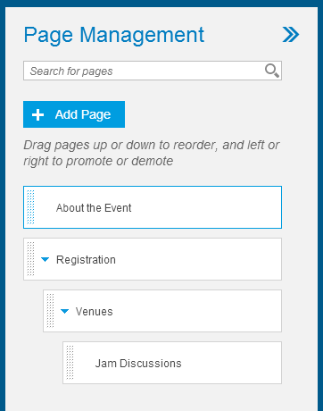

## Revert changes made to the site

You can remove all changes made to the site since it was last published. This option is not available for sites that have never been published.

* 1. In the side-panel menu, click  (Modified since last publish). The icon indicates that the site has been modified since it was last published.
  2. Open the *Publishing Options* panel.
  3. Click *Revert to Last Published Site*, and click *Revert* in the confirmation dialog box.
  4. Click *Refresh Site* in the notification dialog box. Check that the original page settings have been restored and that the *Registration* page appears in the page navigation bar.

## Set a URL for downtime

You can point to any HTML page or URL when the system is offline for maintenance or other reasons. This URL replaces redirection to the default SAP HANA Cloud Portal downtime message page.

* 1. Open the *Site Settings* panel.
  2. In the *URL Redirect When Site is Down* section, you can click the *Default downtime page* link to view the downtime-message page delivered with Cloud Portal, which is used by default when the system is offline.
  3. To redirect to a different page or URL, click  (Edit) and enter the required URL in the framed field.
  4. Click  (Save). You can check the link by clicking the URL, which displays the page in a separate browser tab. You can use the *Revert to default link* to cancel your latest selection and return to the Cloud Portal default downtime-message page

# Appendix: Setting up Your Trial Account

1. In your browser, go to <https://account.hanatrial.ondemand.com/>.  
     
   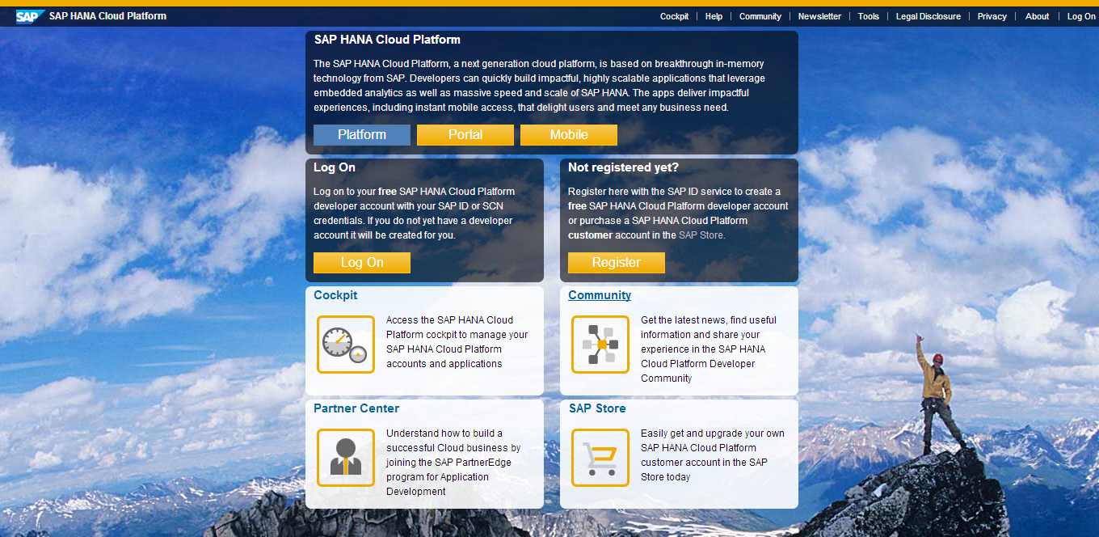
2. Click *Register*.
3. Fill in the form, then scroll to the end of the license agreement and select the checkbox.
4. Click *Register*. You will receive an email notification.
5. Click **Continue**, A message appears with your trial account name.
6. On your account page, in the side-panel menu at the left, click ***Services***.
7. Click *SAP HANA Cloud Portal*.

